SSL
Secure Socket Layer
* It is one of web security Mechanism used for web server and application server
for the Client server applications

*it is an Cryptographic Technology which does encryption and Decryption
*it uses the Protocol--HTTPS Secure Hypertext Transfer Protocol
* SSL configuration is common for types of technology web server except Java Server

SSL.crt-----it is certificate which carries public keys and private keys

1. SSL.crt-(Updated)----(Public key--Encrypt Private Key--Decrypt)

2,CA--Certified Authorities---verisign,Entrust,web Trust-----

CATrust.crt

3.Digital Signatures-----SSC--Self Signed Ceritficates----SSO--SingleSignON

CN,OU,City,state,County,SD,ED

KeyStores
Command line----Java Command---keytool

IBM Key Management—ikeyman

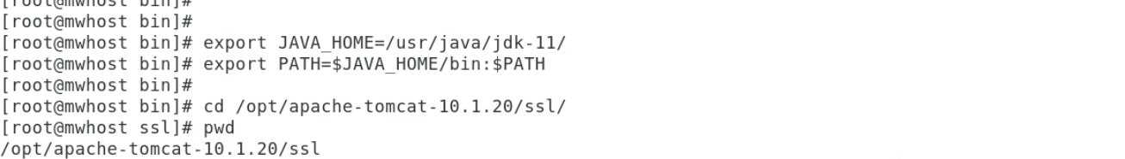

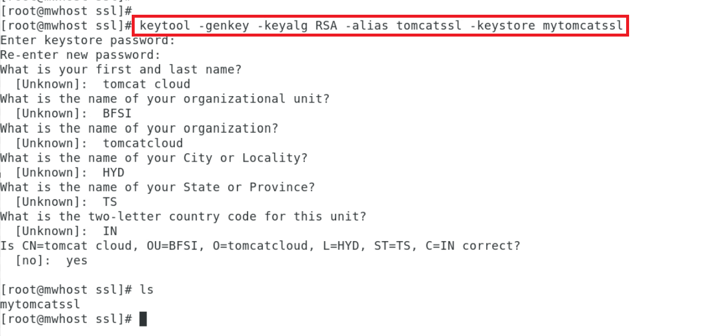
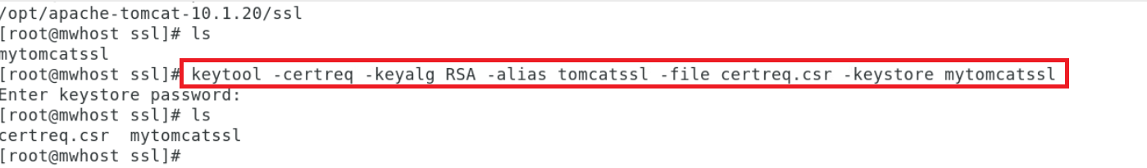
Before passing ssl
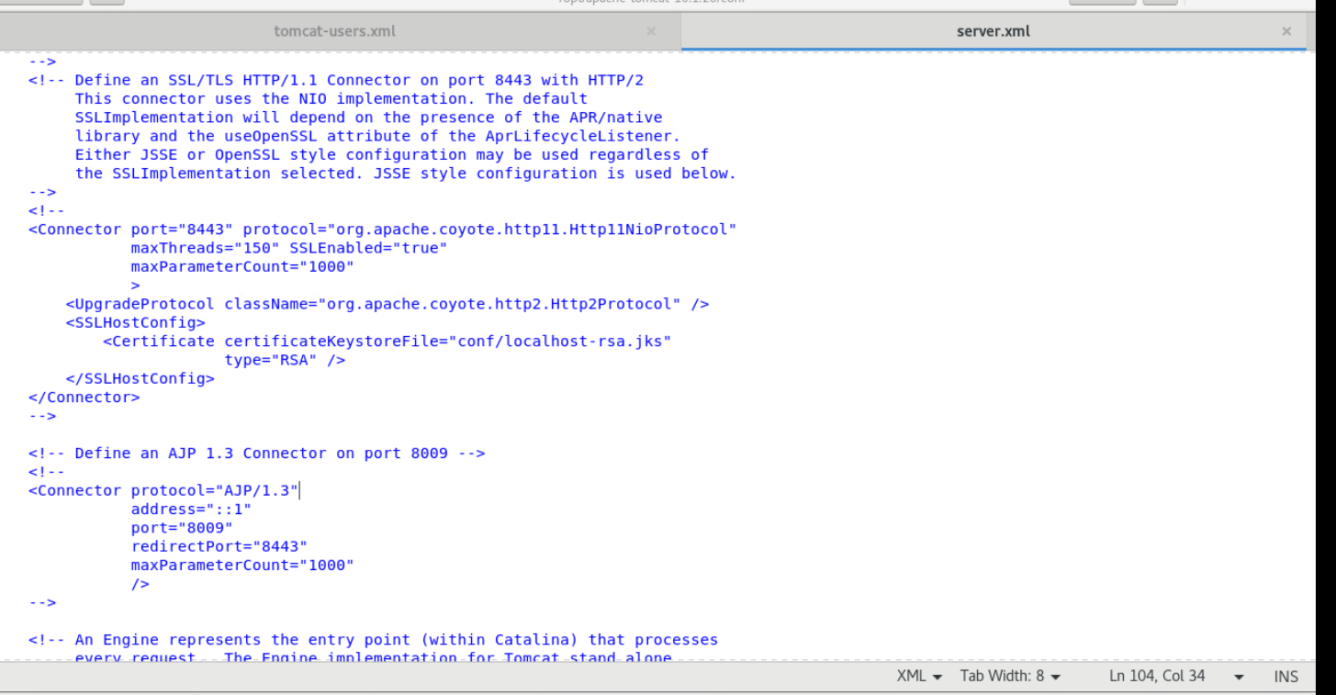

Without SSL

browser(http://www.yahoo.com/index.html)------------>Webserver(index.html)----WLS(yahoo.war)

With SSL

browser(https://www.gmail.com/login.html--us,pwd-Encrypted--Publickey)--------->WEbServer(DigitalSignatures,SSL.crt(PrivateKey--Decrption),CATrustlogin.html)--->

CA--certified authorities( verisign,entrust,webtrust)

one way ssl

1.SSL.crt(Update)

2.CAtrust(branded ceritficate)

2 way ssl

3.SSO or SSC (Digital Signatures)

keystores

Java Keystores(.jks)

it is database file which carries sslcrt,catrust,sso detail and locations

2 jks files needed

T1.jks---->java1234---->locate the SSL crt

T2.jks---->india1234---->locate the CA Trust

IBM utility called IBM key Management Tool

